Business Requirements Document (BRD)
Project: Optimaizer Grader - AI-Powered Assessment Platform

1. Executive Summary
The assessment and grading process represents one of the most significant bottlenecks in modern education, consuming 30-50% of instructor time while often failing to deliver consistent, actionable feedback to students. Optimaizer Grader addresses this critical inefficiency through an intelligent, rubric-driven assessment platform that combines algorithmic precision with instructor-specific pedagogical judgment.
This document outlines requirements for an AI-powered system that functions as a "high-level teaching assistant," automating the mechanical aspects of grading while preserving and learning from human evaluator expertise. The system ingests student submissions, applies complex rubrics with precision, learns from instructor corrections to replicate specific grading styles, and generates structured, constructive feedback for each criterion. By decoupling time-consuming evaluation mechanics from intellectual assessment, Optimaizer Grader enables scalable, high-quality feedback that enhances learning outcomes while reducing instructor burnout by an estimated 60-70%.
The solution serves as a productivity multiplier for educational institutions, transforming grading from a repetitive administrative task into an opportunity for enhanced learning analytics and personalized student development.

2. Project Overview & Educational Context
2.1 Market Landscape & Problem Significance
The global education technology market is experiencing rapid growth, with particular demand for solutions addressing instructor workload and assessment quality. Current grading practices suffer from systemic inefficiencies:
- Time Inefficiency: Instructors spend 15-25 hours weekly grading for medium-sized classes
- Quality Variance: Inter-rater reliability in subjective assessments rarely exceeds 70-80%
- Delayed Learning Cycles: Feedback delayed beyond 72 hours loses 50-60% of its pedagogical impact
- Scalability Challenges: Online education and large lecture formats make personalized feedback economically unfeasible
2.2 Problem Statement Deep Dive
The "grading bottleneck" manifests across multiple dimensions:
Aspect | Current State | Impact
Time Allocation | 30-50% of instructor time spent on grading | Reduced capacity for lesson planning, student mentoring, and research
Consistency | Subjective judgments lead to 15-25% grade variation | Questions of fairness, grade disputes, compromised assessment validity
Feedback Quality | Brief, generic comments due to time constraints | Limited student understanding of specific improvement areas
Scalability | Manual grading limits class sizes and assignment frequency | Constrained educational delivery models and revenue potential
Instructor Wellbeing | Repetitive, high-volume grading leads to burnout | Increased attrition, decreased teaching quality, institutional knowledge loss

2.3 Project Vision & Strategic Objectives
Vision: To become the definitive platform for scalable, consistent, and pedagogically sound assessment across all educational contexts by amplifying—not replacing—instructor expertise.
Objective | Key Performance Indicator | Target
Reduce grading time per assignment | Time reduction percentage compared to manual grading | ≥70% reduction
Improve grading consistency | Inter-rater reliability score when compared to instructor baseline | ≥0.95 Cohen's Kappa
Enhance feedback quality | Average feedback specificity score (1-5 scale) | ≥4.5
Scale assessment capacity | Maximum submissions processed simultaneously | 1,000 concurrent submissions
Instructor adoption rate | Percentage of trial users who convert to regular use | ≥80%

3. Stakeholder Analysis & User Personas
3.1 Primary Stakeholder Groups
Stakeholder | Primary Goals | Key Concerns | Success Metrics
University Professors | Reduce grading workload, maintain academic standards, improve feedback quality | AI accuracy, time to train system, integration with existing workflows | Time saved, student satisfaction scores
K-12 Teachers | Handle large class sizes, provide personalized feedback, meet curriculum standards | Ease of use, alignment with district rubrics, data privacy for minors | Grading completion time, parent feedback
Teaching Assistants | Consistent grading across sections, reduced repetitive work, skill development | Job security implications, learning opportunity preservation | Time allocation to higher-value tasks
Academic Administrators | Improve educational outcomes, optimize resource allocation, demonstrate innovation | Cost-effectiveness, implementation complexity, regulatory compliance | Institutional performance metrics, ROI
Students | Receive timely, specific, actionable feedback, perceive grading fairness | Transparency of AI role, appeal mechanisms, personal data usage | Feedback usefulness ratings, grade satisfaction
3.2 Critical User Personas
Primary Persona: "Professor Martinez"
- Role: Tenured Computer Science Professor at a research university
- Context: Teaches 2 courses with 150 students each, assigns weekly programming assignments
- Pain Points: Spends 20+ hours weekly grading, struggles with consistency across TAs, receives complaints about delayed feedback
- Goals: Reduce grading time by 80%, ensure identical standards across all graders, provide detailed technical feedback
- Success Criteria: System learns his nuanced approach to evaluating code quality and documentation

4. Solution Overview & Value Proposition
Optimaizer Grader transcends conventional autograders through its adaptive pedagogical intelligence. While standard autograders check for binary correctness, our system understands and replicates the nuanced, multidimensional evaluation that characterizes expert human grading.
4.1 Core Value Proposition Components
Component | Traditional Grading | Optimaizer Grader | Value Created
Evaluation Consistency | Varies by grader, fatigue level, time of day | Algorithmically identical against rubric | Fairness, reduced disputes, reliable assessment
Feedback Generation | Brief, often generic comments due to time constraints | Detailed, criterion-specific comments with improvement suggestions | Accelerated learning, reduced follow-up questions
Instructor Adaptation | Fixed, one-size-fits-all scoring algorithms | Learns and mimics instructor's unique style and priorities | Preservation of pedagogical approach, trust building
Scalability | Linear time increase with student count | Near-instantaneous batch processing | Enables more frequent, lower-stakes assessments
Analytics | Limited to gradebook averages | Detailed analytics on common errors, rubric effectiveness | Data-driven curriculum improvement
4.2 Competitive Differentiation
Unlike generic AI writing evaluators or multiple-choice autograders, Optimaizer Grader specializes in:
- Rubric-Anchored Intelligence: Strict adherence to instructor-defined criteria with explainable scoring
- Style Transfer Learning: Adapts to individual instructor preferences through iterative feedback
- Pedagogical Context Awareness: Considers assignment objectives, course level, and learning outcomes
- Human-in-the-Loop Design: Prioritizes uncertain cases for instructor review, maintaining quality control

5. Detailed Requirements Specification
5.1 Business & Process Requirements
ID | Requirement Description | Priority | Success Metric
BR-001 | Reduce average grading time per assignment by minimum 70% while maintaining or improving feedback quality | Critical | Time tracking data from pilot users
BR-002 | Achieve ≥95% consistency with instructor grading standards after training period | High | Cohen's Kappa coefficient in controlled trials
BR-003 | Support integration with at least 3 major Learning Management Systems | High | Successful API connections established
BR-004 | Process batch submissions of up to 1,000 student responses within 60 minutes | Medium | Performance testing results
BR-005 | Generate feedback that students rate as "highly useful" (≥4.0/5.0) | High | Student satisfaction survey results
5.2 Functional Requirements
Core Assessment Engine:
Module | Requirement ID | Description | Acceptance Criteria
Submission Processing | FR-101 | Accept multiple file formats (PDF, DOCX, code files, images) | Supports 10+ formats including .py, .java, .pdf, .docx
Rubric Management | FR-102 | Allow creation of multi-dimensional rubrics with weighted criteria | Rubric builder with drag-and-drop interface
AI Grading Core | FR-103 | Apply rubric algorithmically to generate initial scores | Initial scores within 15% of instructor baseline
Style Learning | FR-104 | Learn from instructor corrections and adjust scoring approach | After 50 graded samples, accuracy improves by ≥25%
Feedback Generation | FR-105 | Generate criterion-specific comments with improvement suggestions | Comments reference specific rubric items and student work
Workflow & Integration:
Module | Requirement ID | Description | Acceptance Criteria
Batch Processing | FR-201 | Grade multiple submissions simultaneously | Processes 100 submissions in <10 minutes
Uncertainty Flagging | FR-202 | Identify submissions needing human review | Flags 10-20% of submissions with confidence <80%
LMS Integration | FR-203 | Push/pull grades and feedback to/from LMS | Compatible with Canvas, Moodle, Blackboard
Collaborative Grading | FR-204 | Support multiple graders with alignment features | Ensures ≤5% variance between different human graders using system
5.3 Non-Functional Requirements
Category | Requirement | Specification
Performance | Submission processing time | <30 seconds per average-length essay submission
Scalability | Concurrent user support | 500 simultaneous instructor users during peak
Reliability | System uptime | 99.9% during academic terms
Security | Data protection | FERPA/COPPA compliance, encryption at rest and in transit
Usability | Learning curve | Instructor proficiency within 2 hours of training

5.4 Data Requirements
Data Type | Source | Volume | Retention
Student submissions | LMS integration | 100GB-1TB annually | 7 years (academic record)
Instructor rubrics | System creation | Minimal | Indefinite while active
Grading history | System operation | 50-100MB per 1,000 submissions | 7 years
Training data | Instructor corrections | 10-100MB per instructor | Indefinite (anonymized)
Analytics data | System logs | 1-5GB monthly | 3 years

6. System Architecture & Technical Design
6.1 System Context Diagram
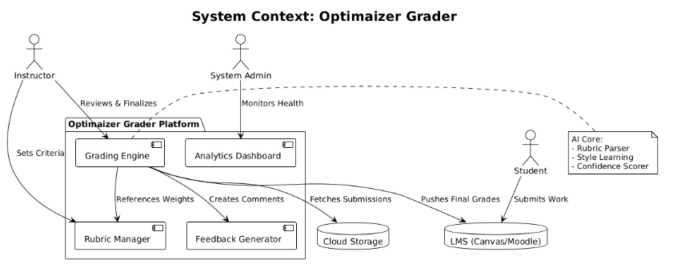
6.2 High-Level System Architecture
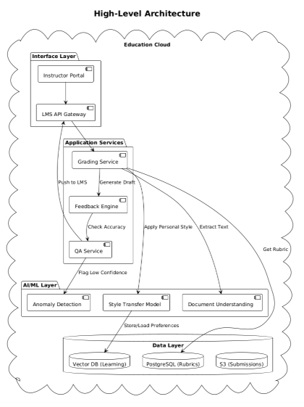

7. Core Processes & Use Cases
7.1 Primary Grading Workflow
Step | Actor | Action | System Response
1 | Instructor | Creates/imports rubric with weighted criteria | System validates rubric structure, saves to database
2 | System | Ingests student submissions from LMS | Files processed, text extracted, formatted for analysis
3 | AI Engine | Applies rubric to each submission | Generates initial scores with confidence levels
4 | System | Flags submissions with low confidence (<80%) | Creates review queue for instructor/TA
5 | Instructor | Reviews flagged submissions, makes corrections | System learns from corrections, updates scoring model
6 | System | Generates personalized feedback for each criterion | Comments reference specific submission elements
7 | System | Pushes final grades and feedback to LMS | Confirms successful transfer, logs transaction
8 | System | Generates analytics on common errors, rubric effectiveness | Presents insights to instructor for curriculum adjustment
7.2 Detailed Use Case: Batch Essay Grading
Use Case ID: UC-101
Title: Grade 150 Philosophy Essays with Customized Rubric
Primary Actor: Philosophy Professor
Preconditions: Rubric created, essays submitted via LMS, system trained on 30 sample essays
Main Success Scenario:
- Professor logs in, selects "PHIL101 Final Essays" assignment
- System shows 150 submissions ready for grading, estimated time: 45 minutes (vs. 15 hours manual)
- Professor clicks "Begin Batch Grading"
- System processes all essays in 35 minutes, flagging 22 for review (confidence <80%)
- Professor reviews flagged essays, adjusts 15 scores, provides additional comments on 7
- System incorporates corrections, updates its scoring model for future use
- System generates detailed feedback for all 150 students, highlighting strengths and specific improvement areas
- Grades and feedback automatically post to LMS
- System generates report showing common logical fallacies across submissions
Postconditions: All students receive grades within 48 hours, professor saves 14+ hours, learning data captured for future improvements

8. Data Model & Analytics Output
8.1 Core Data Entities
Entity | Attributes | Relationships | Purpose
Rubric | ID, Name, Criteria[ ], Weights[ ], Creator, Version | One-to-Many with Assignments | Defines evaluation standards
Assignment | ID, Name, Course, Due Date, Submission Format | Many-to-One with Course, One-to-Many with Submissions | Organizes student work
Submission | ID, StudentID, Content, FileType, Timestamp | Many-to-One with Assignment, One-to-One with Grade | Student work product
Grade | ID, Scores[ ], Overall, Confidence, Feedback[ ] | One-to-One with Submission | Evaluation results
Training Example | ID, SubmissionID, InstructorAdjustments, LearningWeight | Used by ML models | Improves system accuracy
8.2 Analytics Output Examples
Report Type | Metrics Included | Pedagogical Value
Rubric Effectiveness | Criteria discrimination indices, inter-criterion correlations | Identifies redundant or unclear rubric items
Class Performance | Distribution of scores, common error patterns, improvement trends | Informs instructional adjustments
Grader Consistency | Variance between human graders using system, AI-human alignment | Ensures assessment reliability
Student Progress | Longitudinal performance across assignments | Tracks individual and cohort development
System Performance | Grading time, accuracy rates, confidence scores | Optimizes platform effectiveness

9. Implementation Considerations
9.1 Phased Rollout Strategy
Phase | Duration | Scope | Success Criteria
Pilot | 3 months | 5 university departments, limited assignments | 80% instructor satisfaction, 70% time reduction
Expansion | 6 months | Additional disciplines, K-12 pilot | Scale to 1,000+ instructors, maintain accuracy
Enterprise | 12 months | Full feature set, institutional licensing | Revenue targets, market leadership position
9.2 Risk Assessment
Risk Category | Likelihood | Impact | Mitigation Strategy
Academic Integrity | Medium | High | Transparent AI disclosure, human oversight requirement, audit trails
Data Privacy | High | Critical | FERPA/COPPA compliance by design, encryption, access controls
Instructor Resistance | High | Medium | Change management program, pilot incentives, success story sharing
Technical Integration | Medium | High | Standardized APIs, dedicated integration support team
Algorithmic Bias | Low | High | Regular bias audits, diverse training data, transparency reports

10. Success Metrics & Evaluation
10.1 Quantitative Metrics
Metric | Measurement Method | Target | Frequency
Instructor time saved | Pre/post time tracking | ≥70% reduction | Monthly
Grading consistency | Inter-rater reliability scores | ≥0.95 Kappa | Per assignment
Student satisfaction | End-of-course surveys | ≥4.2/5.0 | Per term
System adoption | Active instructor count | 30% growth quarterly | Quarterly
Technical performance | Uptime, processing speed | 99.9%, <30 sec/submission | Continuous
10.2 Qualitative Evaluation
- Instructor testimonials on workload reduction and pedagogical benefits
- Institutional case studies demonstrating improved learning outcomes
- Peer-reviewed research on assessment quality and efficiency gains
- Student feedback on feedback usefulness and learning impact

Document Approval
Role | Name | Signature | Date
Project Sponsor
Lead Academic Advisor
Chief Technology Officer
Product Manager

